Liver |  |  | 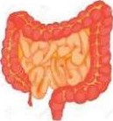 | This is where oxygen gets into the blood.  Carbon dioxide leaves the blood here.
Lungs |  |  | 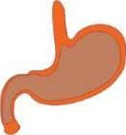 | This control most of the things your body can do.
Small and large intestines |  |  | 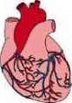 | This pumps blood to all parts of the body.
Heart |  |  | 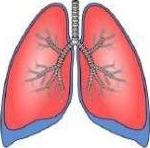 | This organ removes toxins from the blood
Brain |  |  | 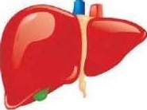 | These help the body to get rid of waste substances. They make urine.
Kidneys |  |  | 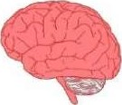 | It starts to break down food.
Stomach |  |  | 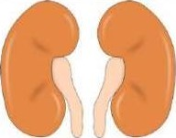 | This is where the body absorbs food and water into the blood.

Liver |  |  |  | This is where oxygen gets into the blood.  Carbon dioxide leaves the blood here.
Lungs |  |  |  | This control most of the things your body can do.
Small and large intestines |  |  |  | This pumps blood to all parts of the body.
Heart |  |  |  | This organ removes toxins from the blood
Brain |  |  |  | These help the body to get rid of waste substances. They make urine.
Kidneys |  |  |  | It starts to break down food.
Stomach |  |  |  | This is where the body absorbs food and water into the blood.

